The University of Azad Jammu and Kashmir Muzaffarabad

Student Name: Qurat Ul Ain Fatima
Roll No: 2024-SE-05
Course Title: Database Systems
Course Code: CS-2204
Lab Instructor: Awais Rathore
Department: Software Engineering

Lab#03

Objective:
The objective of this lab is to understand how the database is created how tables are created inside datbas and how data is inserted into the tables. This is the basic step of creating any kind of database.

Create Database:
Firstly a database name university_labs is created using command.
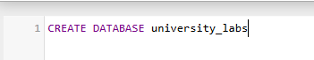
Department Table:
Then the department table is created inside database. Then the data is inserted into the table.
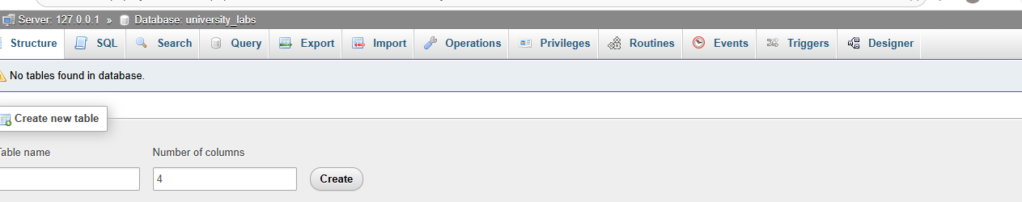

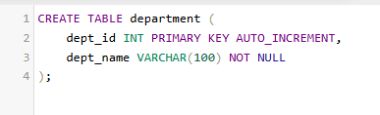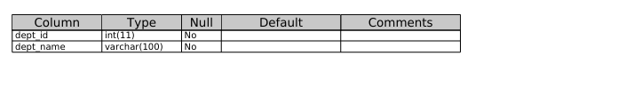
Data:
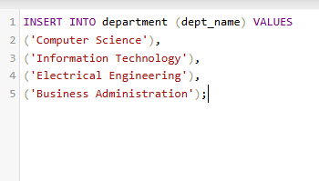
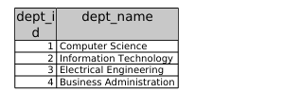

Student table:
The student table is created , and data (id , name ,email , and department id )is inserted into it.
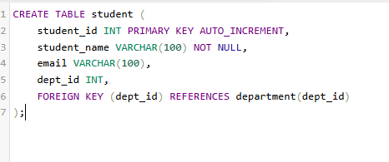
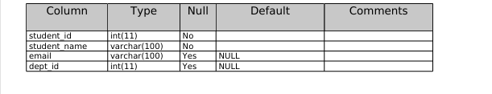

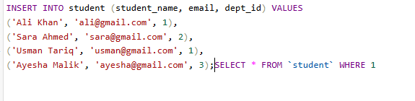
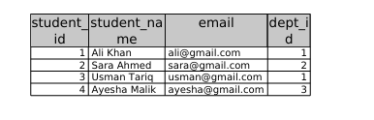
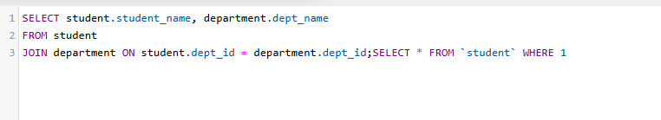

Instructor:
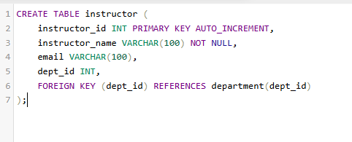
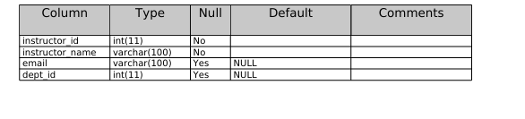
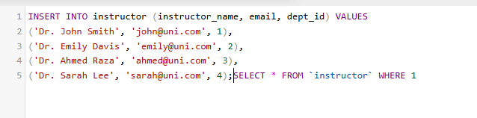
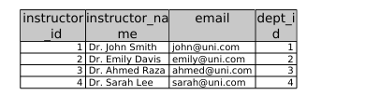

Course Table:

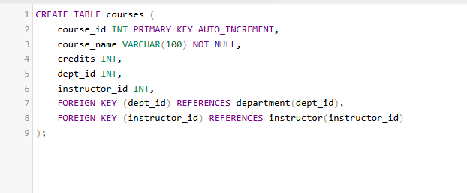
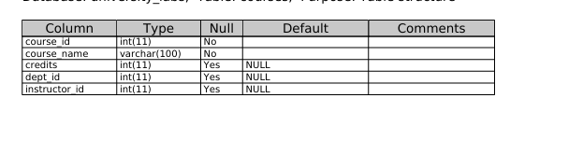
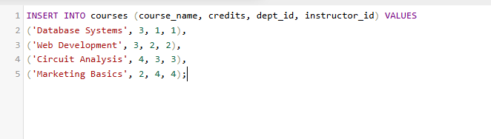
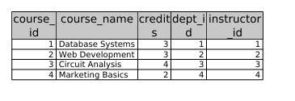

Enrollment:
